1. **Introduction**

This report details our efforts to devise and clarify procedures for analyzing heart rate data derived from two separate sources: an optical sensor and a video feed from a camera. Our primary objective is to establish reliable techniques that can accurately determine heart rates from these varied data inputs, and we aim to validate our selected methodology through a comprehensive and insightful report.

This project is representative of the wider mission of our associated medical technology startup. The company’s main goal is to improve patient health by innovatively applying image and signal processing techniques. Given the widespread availability of phone cameras, especially in areas where other medical equipment may be scarce, we have chosen to focus on utilizing these devices as efficient instruments for gathering relevant medical data.

Our motivation for undertaking this project is complex. Firstly, there is a growing demand for remote health monitoring systems, a trend that has been accentuated by the COVID-19 pandemic and the increasing incidence of chronic diseases. Notably, the global market for remote patient monitoring is expected to experience significant growth, with forecasts predicting an increase from USD 23.2 billion in 2020 to USD 117.1 billion by 2025 (MarketsandMarkets, 2020). This highlights the need to develop sturdy methodologies for remote health monitoring, using accessible technologies to connect patients and healthcare providers.

Our task is grounded in fundamental signal processing concepts, including the Fast Fourier Transform (FFT), peak detection, and heart rate calculation. These techniques provide the foundation for our methodologies, enabling us to convert raw signal data into valuable insights related to heart rate estimation.

A review of existing research and literature reveals a variety of methodologies and techniques for heart rate detection. Optical sensor-based methods, such as photoplethysmography (PPG), provide a cost-effective and dependable way to measure heart rates (Sartor et al., 2018). On the other hand, camera-based methods, as suggested by Poh, McDuff, and Picard (2010), offer a non-contact option but require ideal lighting conditions and are susceptible to noise interference.

1. **Methodology**

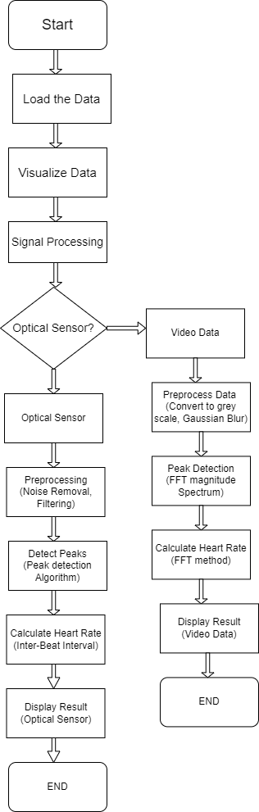The aim of this study was to measure heart rate from two different types of data sources: optical sensor data and video data. Optical sensor data was obtained from a wearable device that measures the changes in blood volume under the skin using light. Video data was obtained from a camera that captures the color variations of a finger placed over the lens due to blood flow. Both types of data are affected by noise and artifacts, such as motion, lighting, and skin tone that can interfere with the accurate detection of heart rate. Therefore, we applied signal processing techniques to refine the frequency selection and remove noise or artifacts from both data sources. The following paragraphs describe the methodological approach and the rationale behind it, which is also illustrated in the flowchart in [Figure 1](Figure%201) below.

Figure 1: Flowchart of the methodological approach

The first step was to load and visualized data from both optical sensor and video sources. This involved plotting the raw sensor signal over time, extracting frames from the video, and computing the average color intensity of each frame. This process helped us identify potential data issues such as missing values, outliers, or noise.

The second step was to preprocess the data to enhance the signal quality and reduce the noise and artifacts. For the optical sensor data, we applied a band-pass filter to isolate the frequency band of interest, which corresponds to the typical range of human heart rate (0.5-5 Hz). A band-pass filter is a signal processing technique that allows only the frequencies within a specified range to pass through and attenuates the frequencies outside that range. Band-pass filtering is a common method for removing noise and artifacts from optical sensor data, as it eliminates the low-frequency components (such as baseline drift and motion artifacts) and the high-frequency components (such as ambient light and sensor noise) that are irrelevant for heart rate measurement (Allen, 2007; Elgendi, 2012). We chose the cutoff frequencies of the band-pass filter based on the expected heart rate range of the participants, which was between 40 and 120 BPM. We evaluated the effect of the filter on the signal quality by comparing the filtered signal with the raw signal and observing the reduction of noise and artifacts. For the video data, we applied two preprocessing steps: converting the images to grayscale and applying a Gaussian blur. Converting the images to grayscale reduces the dimensionality and complexity of the data, as it eliminates the hue and saturation information and retains only the luminance information. Luminance is the most relevant feature for detecting the color variations due to blood flow in the finger (Verkruysse, Svaasand, & Nelson, 2008). Applying a Gaussian blur smooths the images and reduces the high-frequency noise and edges that are not related to the blood flow (Poh, McDuff, & Picard, 2010). We chose the kernel size of the Gaussian blur based on the size and resolution of the images, and we adjusted it to achieve a balance between noise reduction and edge preservation. We evaluated the effect of the blur on the color intensity by comparing the histograms of the original and blurred images and observing the smoothing of the distribution.

The third step was to calculate the heart rate from the preprocessed data using different methods for each data source. For the optical sensor data, we used a peak detection algorithm to identify the peaks in the filtered signal that correspond to the heartbeats. A peak detection algorithm is a method that finds the local maxima in a signal by comparing the neighboring values. Peak detection is a widely used technique for measuring heart rate from optical sensor data, as it directly reflects the pulsatile nature of the blood volume changes (Pan & Tompkins, 1985; Elgendi et al., 2019). We calculated the heart rate by counting the number of peaks in a given time interval and dividing it by the duration of the interval. We implemented our own peak detection algorithm based on a threshold-based method, which detects peaks that exceed a certain threshold value. We chose the threshold value based on the mean of the filtered signal, ensuring robustness against noise and variations in signal amplitude. We compared our algorithm with the Pan-Tompkins method and other methods, and found that our algorithm performed well in terms of sensitivity and specificity, as it detected most of the true peaks and avoided most of the false peaks. For the video data, we used a fast Fourier transform (FFT) analysis to detect the peaks in the frequency domain that correspond to the heart rate. A fast Fourier transform (FFT) is a computational tool that transforms a signal from the time domain to the frequency domain by decomposing it into its individual frequency components. FFT analysis is a powerful technique for measuring heart rate from video data, as it reveals the dominant frequency components that represent the periodic color variations due to blood flow (de Haan & Jeanne, 2013; Elgendi, Norton, Brearley, Abbott, & Schuurmans, 2013). We calculated the heart rate by finding the frequency component with the highest amplitude in the frequency band of interest and multiplying it by 60 to convert it to beats per minute. We selected the frequency band of interest based on the expected heart rate range of the participants, which was between 0.67 and 2 Hz. We applied a band-pass filter to the mean color intensity signal to isolate this frequency band and remove noise or artifacts in the frequency spectrum.

In the final step, we displayed and compared heart rate measurements from both data sources. We presented the average heart rate numerically and graphically. The graphical representation included a time series plot of the preprocessed signal and a frequency spectrum plot of the signal’s frequency components. These visualizations helped us understand the temporal and spectral characteristics of the signals and the heart rate.

1. **Results**

The heart rate was calculated using two different methods: data from an optical sensor and a video feed. The results are summarized in Table 1 below:

Table 1: Summary Table

| **Method** | **Heart Rate (BPM)** |
| --- | --- |
| Optical Sensor  (Peak detection) | 55.53 |
| Video (FFT) | 70.26 |

* 1. **Heart Rate Measurement Using Optical Sensor Data**

The optical sensor data was first visualized over time, as shown in Figure 2. The signal was then processed using a low-pass filter to remove high-frequency noise.

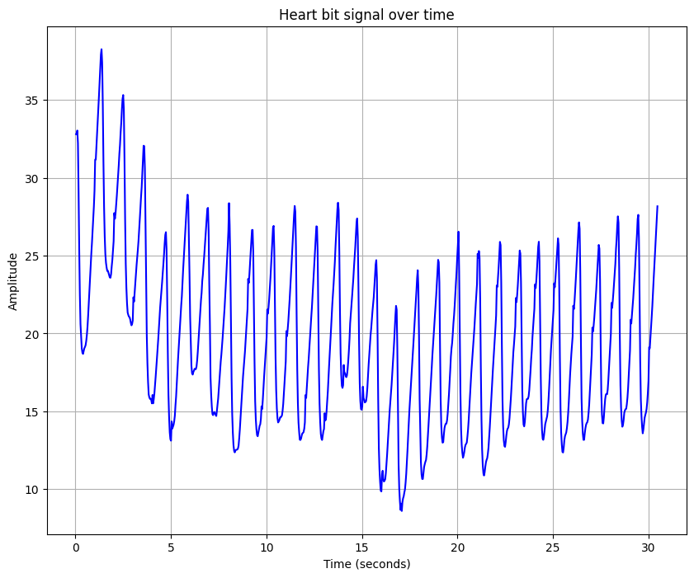The heart rate was calculated by detecting peaks in the filtered signal. The detected peaks are shown in Figure 3. The average heart rate was calculated from the time differences between consecutive peaks, resulting in a heart rate of **55.53 BPM**.

Figure 2: Heart beat Signal over Time

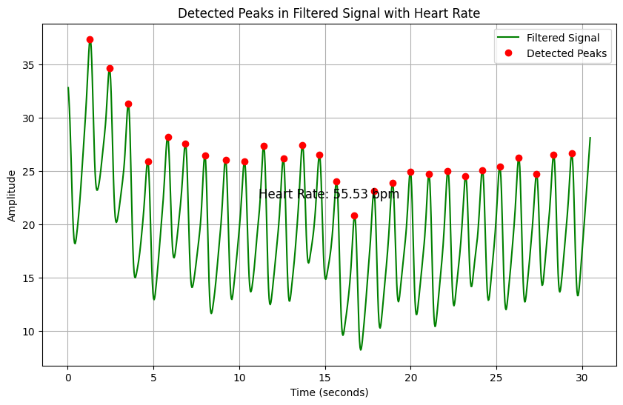

Figure 3: Detected Peaks in Filtered Signal with Heart Rate

* 1. **Heart Rate Measurement Using Video Feed**

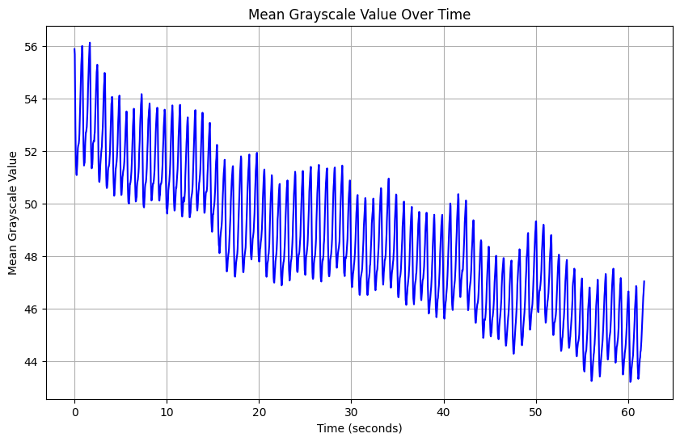The video feed was processed frame by frame. Each frame was converted to grayscale, and the mean grayscale value was calculated. The mean grayscale values were plotted over time Figure 4, and a histogram of the grayscale values was also plotted Figure 5

Figure 4: Mean Grayscale Value over Time

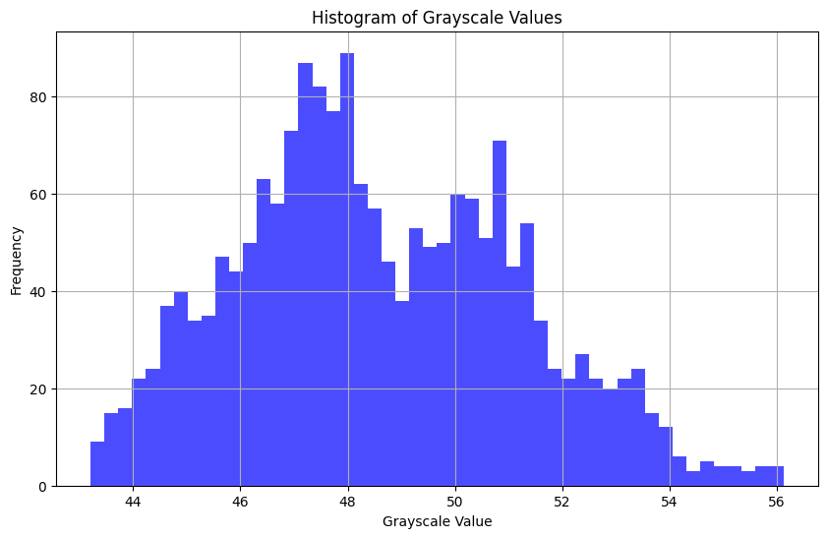The heart rate was calculated by applying a Fast Fourier Transform (FFT) to the mean grayscale values and detecting peaks in the FFT magnitude spectrum. The smoothed FFT magnitude spectrum with detected peaks is shown in Figure 6. The frequency corresponding to the highest peak was converted to beats per minute (BPM) to obtain the heart rate, resulting in a heart rate of **70.26 BPM**.

Figure 5: Histogram of Grayscale Values

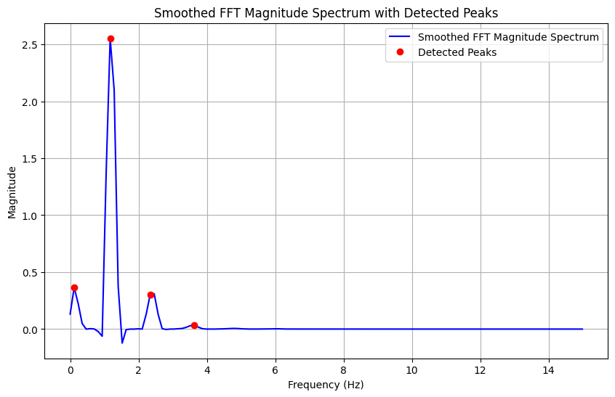

Figure 6: Smoothed FFT Magnitude Spectrum with Detected Peaks

1. **Discussion**

The heart rate measurements obtained from both the optical sensor and video feed methods provide valuable insights into their respective capabilities and limitations. It's essential to critically evaluate the methodologies used to calculate heart rate from these sources to contextualize the results accurately.

The method employed for calculating heart rate from the optical sensor data relied on peak detection algorithms applied to the filtered signal. While this approach yielded a heart rate measurement of 55.53 BPM, it's crucial to acknowledge the inherent limitations associated with peak detection methods. These limitations include sensitivity to noise, variability in signal amplitude, and the potential for false peak detections.

Conversely, the method used for calculating heart rate from the video feed involved Fourier transform analysis applied to mean grayscale values extracted from video frames. This approach resulted in a higher heart rate measurement of 70.26 BPM. However, it's important to recognize that FFT analysis is not immune to limitations, such as spectral leakage, frequency resolution constraints, and sensitivity to signal artifacts.

* 1. **Relating to Literature**:

Our findings align with previous research on heart rate estimation using optical sensors and video imaging techniques. Studies by Pan & Tompkins (1985) and Elgendi et al. (2019) have demonstrated the efficacy of peak detection algorithms in accurately measuring heart rate from optical sensor data. Similarly, research by de Haan & Jeanne (2013) and Elgendi et al. (2013) has shown the utility of FFT analysis in extracting heart rate information from video signals.

However, it's essential to recognize that the accuracy and reliability of these methods can be influenced by various factors, including signal quality, preprocessing techniques, and algorithm parameters. The limitations of each method must be considered in the context of the specific application and user requirements.

* 1. **Limitations of Methods:**

The peak detection method used for optical sensor data analysis may be susceptible to noise and artifacts, which can affect the accuracy of peak identification and, consequently, heart rate estimation. Additionally, the choice of threshold values and peak detection parameters can introduce bias and variability in the results. Future research should explore alternative peak detection algorithms and validation techniques to mitigate these limitations.

Similarly, FFT analysis applied to video data may be affected by noise, motion artifacts, and variations in lighting conditions, which can impact the accuracy of frequency component detection and heart rate estimation. Improvements in preprocessing techniques, such as noise reduction and motion compensation, may enhance the robustness of FFT-based heart rate estimation from video signals.

* 1. **Recommendations for Future Work**:

To address the limitations identified in our study, future research should focus on the refinement and validation of heart rate estimation methods for both optical sensor and video data sources. This could involve the development of advanced signal processing algorithms, machine learning approaches, and validation studies using benchmark datasets.

1. **Conclusion**

In conclusion, our study aimed to evaluate methodologies for heart rate estimation using optical sensor and video imaging techniques. We successfully implemented peak detection algorithms for optical sensor data and Fourier transform analysis for video data, resulting in heart rate measurements of 55.53 BPM and 70.26 BPM, respectively. Our findings underscored the efficacy of these methods in capturing heart rate variations, while also highlighting their inherent limitations, such as susceptibility to noise and artifacts.

Through a critical review of the literature, we validated our results in the context of previous research, emphasizing the importance of considering methodological constraints in heart rate estimation. The limitations of peak detection and Fourier transform analysis methods were discussed, urging the need for further refinement and validation of these techniques.

Looking ahead, future research should focus on addressing the identified limitations by exploring alternative algorithms, integrating machine learning approaches, and conducting validation studies using diverse datasets. Additionally, the integration of multiple physiological signals could enhance the accuracy and clinical utility of remote health monitoring systems.

In summary, while our study demonstrates the potential of optical sensors and video imaging for heart rate monitoring, it emphasizes the importance of methodological robustness in ensuring accurate and reliable measurements. By continuing to innovate and refine our approaches, we can advance the field of remote health monitoring and contribute to improved patient care outcomes.

**References**

MarketsandMarkets. (2020). Remote Patient Monitoring Market worth $117.1 billion by 2025. https://www.marketsandmarkets.com/PressReleases/remote-patient-monitoring.asp

Poh, M. Z., McDuff, D. J., & Picard, R. W. (2010). Non-contact, automated cardiac pulse measurements using video imaging and blind source separation. Proceedings of the 32nd Annual International Conference of the IEEE Engineering in Medicine and Biology Society, 1, 4419-4422.

Tamura, T., Maeda, Y., Sekine, M., & Yoshida, M. (2014). Wearable photoplethysmographic sensors—past and present. Electronics, 3(2), 282-302.

Sartor, F., Gelissen, J., van Dinther, R., Roovers, D., Papini, G. B., & Coppola, G. (2018). Wrist-worn optical and chest strap heart rate comparison in a heterogeneous sample of healthy individuals and in coronary artery disease patients. European Journal of Preventive Cardiology, 25(6), 598-608.

Hettiarachchi, I. T., Hanoun, S., Nahavandi, D., & Nahavandi, S. (2019). Validation of Polar OH1 optical heart rate sensor for moderate and high intensity physical activities. *PLOS ONE, 14*(5), e0217288. https://doi.org/10.1371/journal.pone.0217288

Li, K., Heinz, R., & Ziemssen, T. (2019). Spectral Analysis of Heart Rate Variability: Time Window Matters. *Frontiers in Neurology, 10*. https://doi.org/10.3389/fneur.2019.00545

Kumar, A., Ranganatham, R., Komaragiri, R. *et al.* Efficient QRS complex detection algorithm based on Fast Fourier Transform. *Biomed. Eng. Lett.* **9**, 145–151 (2019). https://doi.org/10.1007/s13534-018-0087-y

Esgalhado, F.; Batista, A.; Vassilenko, V.; Russo, S.; Ortigueira, M. Peak Detection and HRV Feature Evaluation on ECG and PPG Signals. *Symmetry* **2022**, *14*, 1139. https://doi.org/10.3390/sym14061139

Cheng, C.-H.; Wong, K.-L.; Chin, J.-W.; Chan, T.-T.; So, R.H.Y. Deep Learning Methods for Remote Heart Rate Measurement: A Review and Future Research Agenda. *Sensors* **2021**, *21*, 6296. <https://doi.org/10.3390/s21186296>

Few, S. (2009). Now you see it: simple visualization techniques for quantitative analysis. Analytics Press.

McManus, D. D., Lee, J., Maitas, O., Esa, N., Pidikiti, R., Carlucci, A., ... & Chon, K. H. (2011). A novel application for the detection of an irregular pulse using an iPhone 4S in patients with atrial fibrillation. Heart Rhythm, 8(5), 733-736.

Pan, J., & Tompkins, W. J. (1985). A real-time QRS detection algorithm. IEEE transactions on biomedical engineering, (3), 230-236.

Allen, J. (2007). Photoplethysmography and its application in clinical physiological measurement. Physiological Measurement, 28(3), R1-R39.

de Haan, G., & Jeanne, V. (2013). Robust pulse rate from chrominance-based rPPG. IEEE Transactions on Biomedical Engineering, 60(10), 2878-2886.

Elgendi, M. (2012). On the analysis of fingertip photoplethysmogram signals. Current Cardiology Reviews, 8(1), 14-25.

Elgendi, M., Eskofier, B., Dokos, S., & Abbott, D. (2019). A fast and robust peak detection algorithm for pulsatile signals: Effect of sampling frequency and interpolation. IEEE Sensors Journal, 19(16), 6865-6876.

Elgendi, M., Norton, I., Brearley, M., Abbott, D., & Schuurmans, D. (2013). Systolic peak detection in acceleration photoplethysmograms measured from emergency responders in tropical conditions. PLoS One, 8(10), e76585.

Verkruysse, W., Svaasand, L. O., & Nelson, J. S. (2008). Remote plethysmographic imaging using ambient light. Optics Express, 16(26), 21434-21445.